/*
* Assignment 10 - using Functions
* @author: Shyanne Bean
* @date: 11/29/21
*/

#include <stdlib.h>
#include <stdio.h>

//Function: Prompt User for Conversion Unit
int userPrompt(int input) {
//user prompt
printf("\nPlease select the unit of measurement you would like to convert to.\n");
printf("0 - Celsius\n");
printf("1 - Farenheit\n");
printf("2 - Quit\n\n>> ");
scanf_s("%i", &input);

return input;
}

//Function: Error if User Input != 0, 1, or 2
int errorPrompt(int input) {
//error dialogue
while (input != 0 && input != 1 && input != 2) {
printf("Sorry, that's not an option. Please select either \"0\", \"1\", or \"2\".\n>> ");
scanf_s("%i", &input);
}

return input;
}

//Function: Prompt for Temperature
double temperaturePrompt(int input, double temperature) {

//Prompt for temperature in Farenheit
if (input == 0) {
printf("\nYou have opted to convert to Celsius. Please input the temperature in Farenheit.\n>> ");
scanf_s("%lf", &temperature);

return temperature;
}

//Prompt for temperature in Celsius
if (input == 1) {
printf("\nYou have opted to convert to Farenheit. Please input the temperature in Celsius.\n>> ");
scanf_s("%lf", &temperature);

return temperature;
}
}

//Function: Convert Celsius to Farenheit
double celsiusToFarenheit(double celsius) {
return (((9.0 / 5.0) * celsius) + 32.0);
}

//Function: Convert Farenheit to Celsius
double farenheitToCelsius(double farenheit) {
return ((5.0 / 9.0) * (farenheit - 32.0));
}

//Function: Prompt for loop confirmation
int loopPrompt(int loop) {
//end loop prompt
printf("\nIf you would like to convert another temperature (max: 10 values), please input \"1\".\n");
printf("Otherwise, input \"0\", or any other integer, to finish and view results.\n>> ");
scanf_s("%i", &loop);
return loop;
}

printResults (int countC, int countF, double startingCelsius[], double startingFarenheit[], double convertedCelsius[], double convertedFarenheit[]) {

//if program added to countC, run results
if (countC > 0) {
printf("\nConverted Temperatures (Farenheit)\n");
for (int i = 0; i < countC; i++) {
printf("F: %lf", startingFarenheit[i]);
printf(" . . . ");
printf("C: %lf\n", convertedCelsius[i]);
}
}

//if program added to countF, run results
if (countF > 1) {
printf("\nConverted Temperatures (Celsius)\n");
for (int i = 0; i < countF; i++) {
printf("C: %lf", startingCelsius[i]);
printf(" . . . ");
printf("F: %lf\n", convertedFarenheit[i]);
}
}
}

//Function: Main Thread
main() {

//Introduction
printf("Hello there! Let's convert some temperatures, shall we?\n");

//Initializing variables
int loop = 1; //loop to act as a boolean for deciding whether to loop (initially set to 1 so that loop runs on startup)
int count = 0; //loop number, cannot exceed 10
int countC = 0; //loop number, cannot exceed 10
int countF = 0; //loop number, cannot exceed 10
int input = 3; //input to act as a boolean for deciding between celsius(0) and farenheit(1) (initially set to 3 so that user input is required)
double temperature = 0.0; //user input temperature data
double startingCelsius[11]; //array to hold starting temperature values in Celsius
double startingFarenheit[11]; //array to hold starting temperature values in Farenheit
double convertedCelsius[11]; //array to hold converted temperature values in Calsius
double convertedFarenheit[11]; //array to hold converted temperature values in Farenheit

//loop to obtain multiple data points
while (loop == 1) {

input = userPrompt(input);
input = errorPrompt(input);

if (input == 0 || input == 1) {

temperature = temperaturePrompt(input, temperature);

if (input == 0) {
startingFarenheit[countF] = temperature;
convertedCelsius[countF] = farenheitToCelsius(temperature);
countF++;
}

if (input == 1) {
startingCelsius[countC] = temperature;
convertedFarenheit[countC] = celsiusToFarenheit(temperature);
countC++;
}
}

if (input == 2) {
break;
}

//if count exceeds max array length, break loop before adding to count
if (count > 10) {
break;
}

loop = loopPrompt(loop);

count++;
}

printResults(countC, countF, startingCelsius, startingFarenheit, convertedCelsius, convertedFarenheit);

//end program
system("pause");
}

[There are only two screenshots, my program runs once for all values instead of having to be run multiple times for each temperature conversion.]
SCREENSHOT 1: Data Values 1 – 3, Loop = True
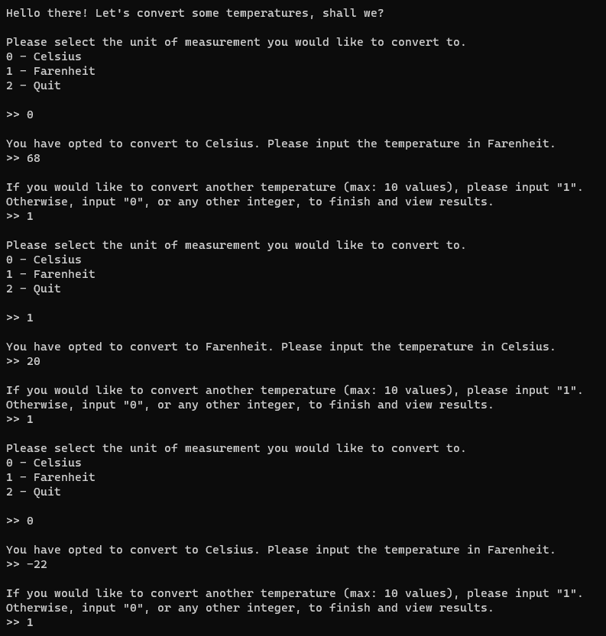
SCREENSHOT 2: Data Value 4, Loop = True, Quit